CAPGEMINI GENERATIVE ENGINE – USEFUL LINKS AND COMMANDS

PREREQUISITE:
- Create your own API key under Studio/Settings from
https://generative.engine.capgemini.com/
- Ensure to check whether you have sufficient tokens for the API call
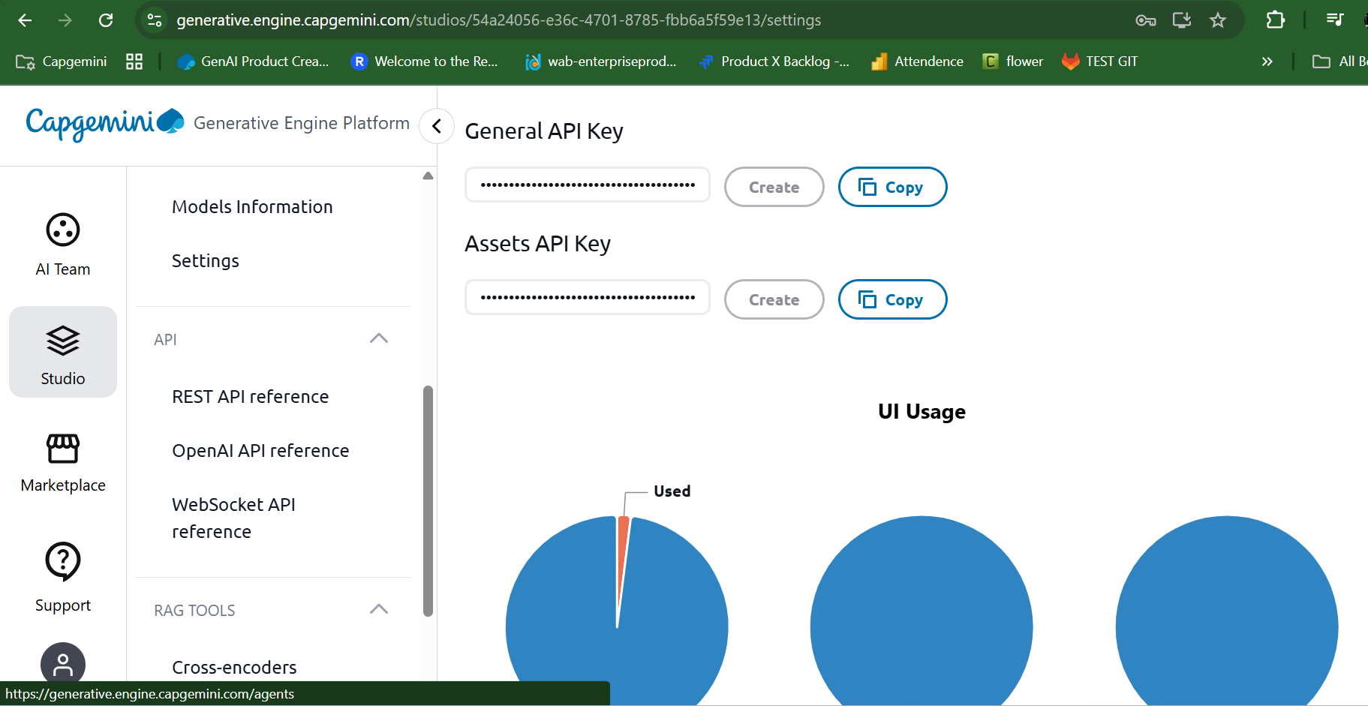

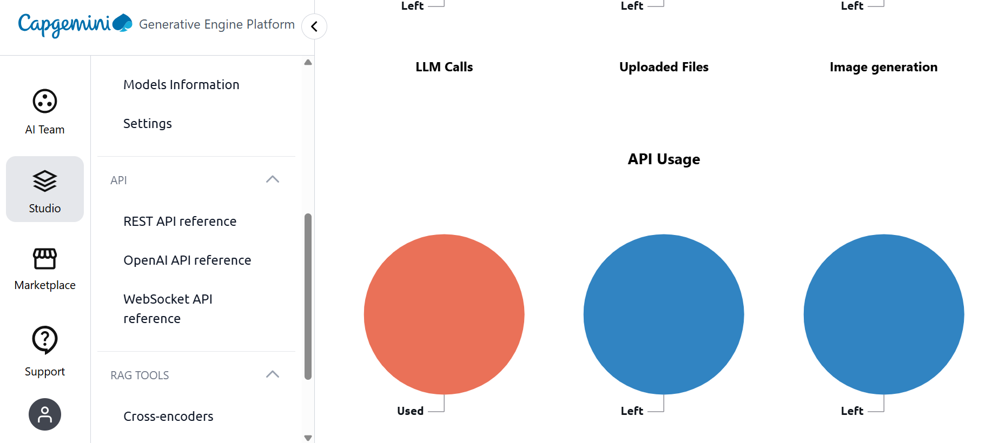

LIST OF EMBEDDING MODELS AND LANGUAGE MODELS AVAILABLE
https://generative.engine.capgemini.com/studios/54a24056-e36c-4701-8785-fbb6a5f59e13/documentation/models

ENSURE TO CHANGE YOUR MODELS IN litellm.env and restart litellm containers
Please note the MODEL NAME always starts with openai/any_model_name_here only
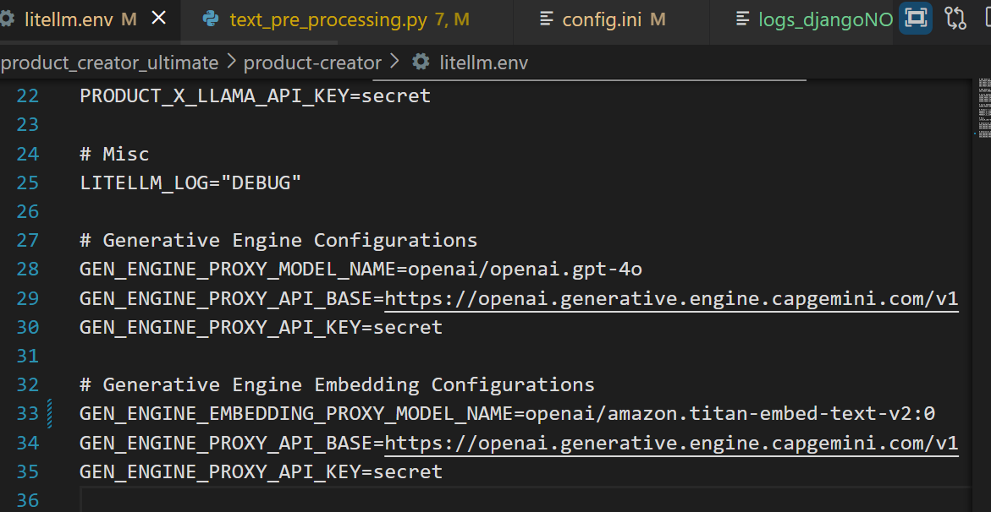
After making any changes in the litellm.env , ensure to restart LiteLLM container and if needed capture the logs
- task product:local:restart:litellm
- docker logs --follow creator-litellm > logs2611_1.txt 2>&1

Add your generated key in secret.env file
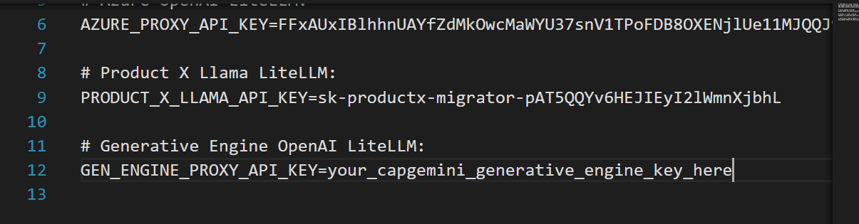

SWAGGER DOCUMENTATION
https://generative.engine.capgemini.com/studios/54a24056-e36c-4701-8785-fbb6a5f59e13/documentation/openai-openapi

CURL COMMANDS TO CHECK CAPGEMINI GENERATIVE ENGINE ENDPOINTS

TO GET ALL THE EMBEDDING MODELS
export TOKEN="your token here"
curl --silent \
-X GET "https://openai.generative.engine.capgemini.com/v1/embeddings/models" \
-H "Authorization: Bearer $TOKEN" \
| jq .

TO CHECK ANY EMBEDDING MODEL WITH SOME TEXT FOR EMBEDDINGS CREATION

export TOKEN="your token here"
curl --silent \
-X POST "https://openai.generative.engine.capgemini.com/v1/embeddings" \
-H "Authorization: Bearer $TOKEN" \
-H "Content-Type: application/json" \
-d '{
"model": "amazon.titan-embed-text-v2:0",
"input": "This is a sample embedding request"
}' | jq .

EMBEDDING MODEL 2 CHECK
export TOKEN="your token here"
curl --silent \
-X POST "https://openai.generative.engine.capgemini.com/v1/embeddings" \
-H "Authorization: Bearer $TOKEN" \
-H "Content-Type: application/json" \
-d '{
"model": "amazon.titan-embed-text-v1",
"input": "hello world"
}' | jq .

TO GET ALL TEXT MODELS
export TOKEN="your token here"
curl --silent \
-X GET "https://openai.generative.engine.capgemini.com/v1/models" \
-H "Authorization: Bearer $TOKEN" \
| jq .

TO CHECK ONE TEXT MODEL
export TOKEN=" mHQn0JneDtaxJLi6FOjkU89NOfLeeLlN9FfI4eHW"
curl --silent -X GET \
"https://openai.generative.engine.capgemini.com/v1/models/openai.gpt-4o" \
-H "accept: application/json" \
-H "Authorization: Bearer $TOKEN" | jq .
IN POWERSHELL: working one
$TOKEN="mHQn0JneDtaxJLi6FOjkU89NOfLeeLlN9FfI4eHW"
curl.exe `
-X GET `
"https://openai.generative.engine.capgemini.com/v1/models/openai.gpt-4o" `
-H "accept: application/json" `
-H "Authorization: Bearer $TOKEN"

Powershell enterprise way:
$TOKEN="mHQn0JneDtaxJLi6FOjkU89NOfLeeLlN9FfI4eHW"

$headers = @{
Authorization="Bearer $TOKEN"
accept="application/json"
}

Invoke-RestMethod `
-Uri "https://openai.generative.engine.capgemini.com/v1/models/openai.gpt-4o" `
-Headers $headers `
-Method Get

TO CHECK ANY TEXT MODEL WITH A MESSAGE
export TOKEN="jorwgtZ1pU8UaEhJEt7IS5ErUgzeg3yw6ysSZllV"
curl --silent \
-X POST "https://openai.generative.engine.capgemini.com/v1/chat/completions" \
-H "Authorization: Bearer $TOKEN" \
-H "Content-Type: application/json" \
-d '{
"model": "openai.gpt-4o",
"stream":false,
"messages": [{"content":"2+2=?","role":"user"}]
}' | jq .
$TOKEN="mHQn0JneDtaxJLi6FOjkU89NOfLeeLlN9FfI4eHW"

curl.exe -X POST `
"https://openai.generative.engine.capgemini.com/v1/chat/completions" `
-H "Authorization: Bearer $TOKEN" `
-H "Content-Type: application/json" `
-d '{"model":"openai.gpt-4o","messages":[{"role":"user","content":"Say hello"}]}'

